
January 2015 Volume IX, No. 1

Among Friends

WELCOME,  Happy  NEW MEM  Join us for our monthly Friends meetings | OUR CUSTOMERS ARE OUR FIRST PRIORITY  by Jody Bell, Branch Manager  In 2014 CLP introduced the Philosophy and Standards of Service Excellence, which means our customers are our first priority! | 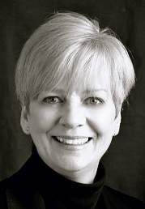
meetings  Saturdays at 10 am: January 10  February 7  March 7    EVERYONE IS WELCOME | As we strive to improve customer service, one of our goals is to eliminate “customer apologies.” In other words, “We are here to provide a service; please don’t think you’re bothering us.” On page 2 you will find a blog written by Holly Anderton, a well-respected colleague of mine, who tells us why there is no need to apologize to your librarian.  Meet Dan Santilli, Our New Part-Time Librarian  Dan was born in Wilkinsburg and lives in Oakmont. He earned an MLIS (Master of Library and Information Science) at Pitt in 2005, and works part-time at both the Squirrel Hill and East Liberty branches of the CLP.  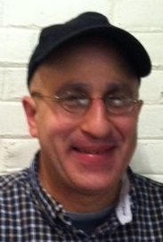  A good library is a place, a palace where the lofty spirits of all nations and generations meet.  Samuel Niger 1883-1956

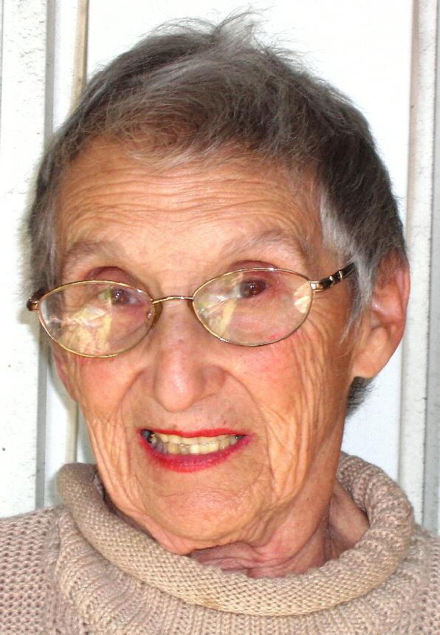 | PRESIDENT’S MESSAGE  by Marion Damick  It's another year. Well, everyone knows that, but do YOU know all that your libraries can provide you? (music up). | EDITOR’S MESSAGE  by Joan Schwartzman  Should auld acquaintance be forgot  and never brought to mind?  Should auld acquaintance be forgot and days of auld lang syne?  For auld lang syne, my dear, | 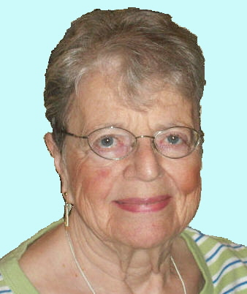
Well, I'm going to let you in on what we hope won't be a secret, but will be known throughout our readership -- and maybe beyond. Way, way beyond -- but I digress.  Ask your librarian anything; she/he will probably have an answer. How about language classes? Answer: Polish, Mandarin, Spanish -- plus more at other branches. Lectures? Genealogy for one; Civil Liberties Civic Classes for another; just ask for what you want, and they'll try to provide it. Check the Adult Programs column in this publication for more.  Taxes are coming, sooner than you would like, and who's to help? -- the people in the library! You knew that.  Of course, there are free yoga classes, book groups, and on and on. What I'm trying to say is make this year one of "new exploration" -- in your local library (Squirrel Hill, that is). Gray and cold as the weather may be, we can start 2015 with a new view and "up" attitude of exploring your own library!  Happy New Year! |  | for auld lang syne,  we'll take a cup of kindness yet,  for auld lang syne.  Robert Burns 1759-1796  We all know this song, which we sing on New Year’s Eve. It’s a happy way to say “Let’s toast each other for old times’ sake”. For four more stanzas and some translations from the Scottish, go to  http://www.carols.org.uk/auld_lang_syne_song.htm.  It is at the New Year that we all make resolutions, hoping that we can keep them for a while. This year we can make a resolution to read and help ourselves to use our library more often. Our librarians are ready to help you find a book on any subject in which you are interested. All you have to do is ask!  Have a wonderful New Year and don't forget our library.
Published by the Friends of the Squirrel Hill Library, 5801 Forbes Avenue, Pittsburgh, PA 15217 412-422-9650
editor: Joan Schwartzman membership, email notices, and mailing list: Allison Marciszyn
production: Lorraine S. Caplan, Dean Damick, Marion Damick, Allison Marciszyn, Rita Motor, Margie Spenser, Serena Spenser
websites: www.carnegielibrary.org/locations/squirrelhill and www.pittsburghusedbooks/friends
e-mail: friends@pittsburghusedbooks.com membership email(Allison): SqHiFriendsLib@gmail.com
Friends online storefront: www.amazon.com/shops/sqhill used book email (Pat): SQhillfr@gmail.com
The online newsletter is at www.pittsburghusedbooks.com/newsletters.
January 2015 Among Friends Volume IX, No. 1

Don’t Apologize to Your Librarian
by Holly Atherton

I find serving the public in the library to be an extraordinarily rewarding job. The vast majority of library patrons that I meet are kind, inquisitive, grateful, and generally lovely. In fact, sometimes they can even get sheepish or apologetic about what they don’t know or do. And so this post will serve to say that we’re okay with all of it, really! The Library would just be a big empty building without you! We’re glad you are here.

Below are some apologetic phrases we hear, and the reasons why there is no need to apologize to your librarian.
- I don’t have time to read. This is often muttered with a hint of guilt, and sometimes this phrase will include a lack of eye contact. But listen. We’re okay with that, really! We won’t judge you. Even librarians get into reading slumps. We find ways to dig out of our slumps, and then we share them with you. Library eBooks, of course, can be a time-saver. If you have them on your tablet or smart phone, they are likely always with you -- you can read a couple of pages in line at the post office or grocery store, though we don’t recommend reading while stuck at a red light. If you need a change of pace, listen to an audio eBook or an audio book on CD.
- I don’t like to read. We are totally okay with you telling us this, but we kind of/sort of don’t believe you. Like police are trained to protect and serve, librarians are trained to believe that there is one book for everyone. It’s our job to find that book! Maybe you need to try something new! A graphic novel, a staff recommendation, or a Read-Alike* for that really popular novel might do the trick. Okay, and maybe we need to broaden our definition of book. Because maybe you just aren’t in the mood to read or listen to books. You can still get your literacy fix at the Library. We have zinio & freegal (free subscriptions to e-magazines and free music downloads), CDs and DVDs. We are serious about celebrating multiple types of literacy!
- I haven’t been to the library in a long time. Whenever I hear this one I just say: “Welcome back!” We understand that the majority of people live rushed, busy lives, so we don’t judge you if you can’t make it to the library every day. As mentioned previously, we have a vast online presence, with loads of options to entice library use from anywhere. We also are working hard to get out of our doors and into your community, to make it easier for you to find us. With all of that, we still host tons of events, programs, meetings, workshops, puppet shows, music and dance performances, discussions – books or otherwise and general fun for all ages – to entertain and enlighten all of those who visit us in the building proper. Whether you’ve been away for a day or for 30 years, we heartily say welcome back! Let us show you around!
- I’m sorry to bother you. Goodness, no, you are not bothering us. We are at the desks in public areas so that we can be of help to you. We might be working on a project, but that is just to stay busy until the next patron comes along and needs our help.
- I have fines. We do too! Now it’s your turn to not judge us. We are here every day, but we check out so many things that we just can’t remember what is due back when. In my former life as a teen librarian, I would visit middle school classrooms to promote the library. On a particular visit, I was telling a group of 7th graders that it’s okay to have fines, because a) we have options for teens who have fines, such as Teen Summer Reading Fine Forgiveness and the Fine Alternative Program, and b) I get fines all the time! A very astute 7th grader said: “What!?!?!?! You get fines?!?!?! That’s stupid.” This may be a fair assessment, but it also serves to show that if we judged you, we’d be the pot calling the kettle black.
- I can’t find… this book; the restroom; meeting room A; a way out of the building. One is apt to get turned around, or have questions while using any of our libraries, if one is not accustomed to it. Think of our Library as a microcosm of Pittsburgh. It can be quite confusing to find your way around. And if you think of us as a microcosm of Pittsburgh, you’ll know that Main Library, or any Library locals (staff), like Pittsburgh locals, will smile knowingly and be happy to help you find your way. You might even pick up a few tips or tricks while we’re at it.
Happy apology-free library visiting!

*See Mark Russell’s explanation of Novelist on page 5.

New Magazine Preview  by Mark Russell  Starting in 2015, three new titles will be added to the general magazine collection. These new magazines were selected based on customer input and availability. The first new title is Creative Knitting. Published quarterly by Annie’s Crafts, Creative Knitting features ideas and patterns for both novice and experienced knitters. Another new addition is Bicycling. This magazine includes reviews of bikes and gear, as well as training articles and expert advice for both road and mountain cyclists. Our final addition is an old favorite, Popular Mechanics. This magazine has been in circulation for over 100 years, and features information on popular technology and do-it-yourself projects.  2 | Other Magazine News  Lately, the magazine racks have looked amazing, full and inviting, because the newest issue stays in the library, going back on the rack when it’s not being read. Once the next edition is published, the older “circulates”.  If you just can’t wait, you might try reading the newest edition on your computer or smartphone.  CLP has more than 300 free digital magazines in “zinio” at carnegielibrary.org/eClp/enewsstand/.
January 2015 Among Friends Volume IX, No. 1
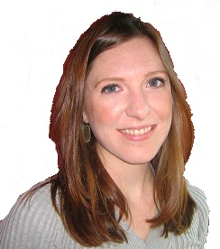 | Children and Teen Services Winter News  by Rachel Nard  The Children’s Room and Teen Services Work Together to Serve Tweens  There have been many exciting happenings in children and teen services at CLP Squirrel Hill. In addition to our regular programming, we have been focusing on creating and implementing programs specifically for our Tween community (library users age 8-12). In an effort to engage our Tweens and provide library programs that support the
curricula of local schools, we decided to focus on STEAM-based programming. Taking a dynamic and multifaceted approach to learning, STEAM stands for Science Technology Engineering Art and Mathematics.

Recently, the Friends of the Squirrel Hill Library helped us purchase some new tech toys for our Tween STEAM programming. These include a hive of BeeBots, an interactive, bee-shaped robot that introduces kids to computer coding and how robots work; BristleBots, a tiny easy-to-assemble robot that serves as a great tool for diving into the wonderful world of robotics; and several Squishy Circuits kits, which allow kids to learn about the basics of electricity, providing a hands-on, sensory-based platform for creating a full circuit and exploring how electricity works using conductive and insulating play dough.

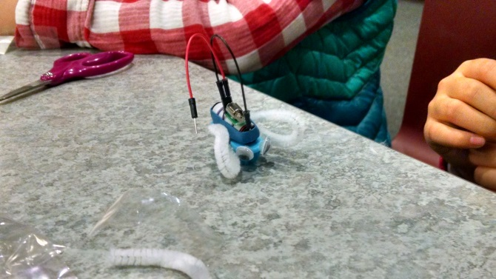  A BristleBot from a Tween STEAM program | 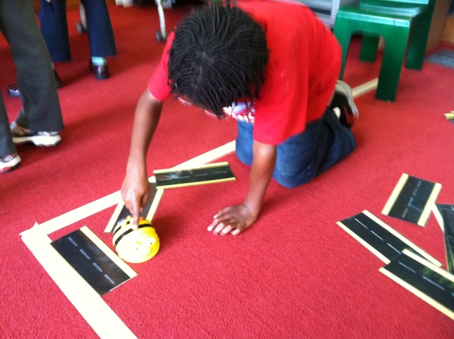  Experimenting with a BeeBot robot | 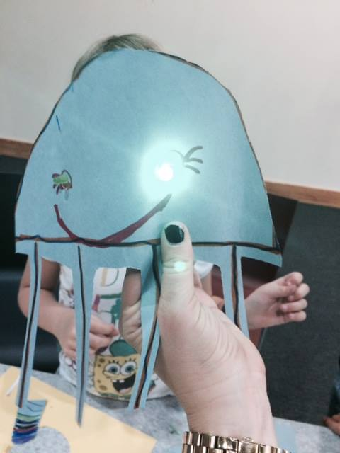  Creating | 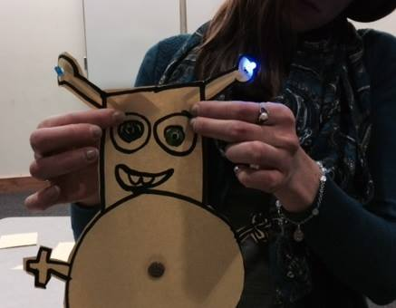paper circuits | 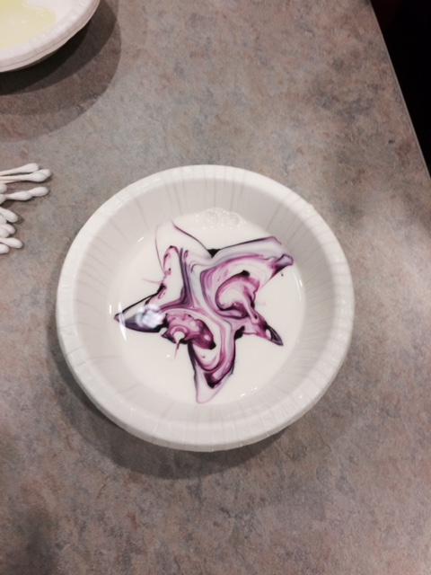  Color Science | 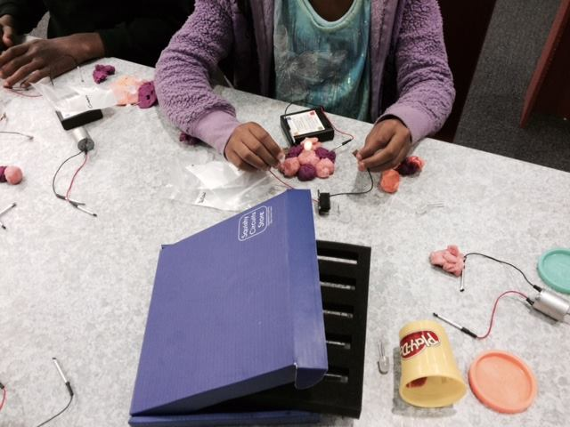  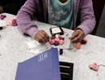  Squishy Circuits

Having these new resources at our fingertips has provided a very successful expansion of library programming for our growing Tween audience in the Squirrel Hill community. In November, we were able to offer a series of STEAM-based programs designed just for Tweens. These programs were great fun and well attended. We explored many different topics, including robotics, snap circuits and squishy circuits, 3D printing, and color science.

Each program starts with the sharing of a story from an age-appropriate book. Students then move through a series of hands-on learning stations. Kids really like the learning stations, which allow them to practice their science process skills like observing, recording data, asking questions, making hypotheses, designing , experimenting, measuring, and more. They like playing the part of the scientist. We support and build upon the learning that happens in the classroom. We are looking forward to getting even more kids excited about science!

Our STEAM programs are not limited to Tweens. We also provide regular programming opportunities for the Children’s Institute and Friendship Circle, two organizations that serve special needs children and teens in our community. Many of the STEAM-based materials have been very useful in these programs, especially the hive of BeeBots. BeeBots are a wonderful tool for varied, sensory-based, hands-on learning. The tactile nature of the BeeBots makes them a very accessible robot for a wide range of learners and ability levels, perfect for the groups we see from the Children’s Institute and Friendship Circle.

These tech tools have also been widely used in outreach programs to local schools, including Environmental Charter School’s Extended Day (E-Day) program and Yeshiva Girls’ School. E-Day is a daily program in which kids are able to stay after school and do activities, get started on homework, and use the computer lab. Once a month, we visit and offer STEAM-based library programs to kids in grades K-5. We see grades 1-12 at Yeshiva Girls’ School monthly, offering STEAM-based activities during lunch periods. Students and staff alike are enjoying the opportunity to explore Squishy Circuits, BeeBots, paper circuits, and many related concepts.
~
In addition to STEAM-based programming, we have all sorts of fun things to do at the library for children and teens alike. Join us for these winter programs:

Celebrate: Beach Party  Join us as we chase away the Winter Blues  with an indoor Beach Party!  Wednesday, January 28th from 4:15 – 5:15 PM  Focuses on babies through 5th graders,  but all ages are welcome.  Tuesday Teen Scene  During the winter months, stop by the Teen Area  for our weekly Tuesday Teen Scene program  from 3:30 – 5:00 PM,  where teens can use the Wii,  hang out with friends,  and do crafts. | Regular Storytimes through April  Join us for stories, songs, rhymes, and all sorts of wiggly fun.  Preschool Pals  Mondays 1:30 PM  Children 3 – 5 years with their grownups  Terrific Tales for Toddlers  Tuesdays 10:30; repeats at 11:30  Toddlers 18 months – 3 years with their grownups  Baby and Me  Thursdays 10:30; repeats at 11:30  Babies birth – 18 months with their grownups  Family Storytime  Saturdays 11 AM  Children birth – 6 years with their grownups
3
3
January 2015 Among Friends Volume IX, No. 1
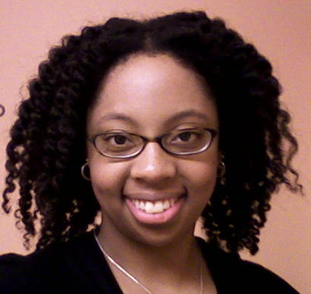 | ADULT PROGRAMS  January – March 2015  by Aisha Hallman  Programs begin at 6:30 unless otherwise noted.  Where registration is required, speak to a librarian, call 412-422-9650,  or email us at squirrelhillprograms@carnegielibrary.org | 

Our Let’s Read English classes will be back in January. We will meet on the 1st Monday of each month at 6 PM. If English is not your native language and you like to read, join us to read one book each month and then meet to discuss the story, improve your vocabulary, and practice your English reading and conversational skills. The first title will be The Five People You Meet in Heaven by Mitch Albom.

Interested in beginning a journey of personal exploration, learning, and adventure that will result in lasting memories for your family and others? Join our Writing a Legacy of Life class which meets the 1st and 3rd Tuesdays of the month from 1-3 PM. No previous writing experience is necessary.

Zentangle classes are back! Melt your stress away with innovative art meditation! Zentangle is an easy-to-learn way to create beautiful images by drawing structure patterns through repetitive pen strokes. There are three sessions:

1. 2nd and 4th Tuesdays in January and February from 1-2:30 PM (January 13, January 27, February 10, February 24)

2. 2nd and 4th Tuesdays in March and April from 1-2:30 PM (March 10, March 24, April 14, April 28)

3. One Thursday evening in January, February, March, and April from 6-7:30 PM (January 15, February 12,
March 12, April 16).

Due to limited space, registration is required. Please sign up for only ONE session.

In March, join us for Civics for Grownups. The classes will be held on Thursdays: March 5, 12, 19, and 26 at 6:30 PM. The theme of the classes is “The Government and You: Roles, Rights and Responsibilities”. The first class will focus on the 1st Amendment and free speech; the second will focus on the 4th Amendment and warrantless searches; the third will focus on the 6th Amendment and right to legal counsel; and the last will focus on surveillance and the right to privacy.

We’re getting a new language class this year! Spanish for Beginners will meet on the 1st & 3rd Wednesdays of the month at 6:30 PM.
Language Classes
Polish for Beginners  1st & 3rd Mondays  at 6:30 PM  starts february 2nd | Spanish for Beginners  1st & 3rd Wednesdays  at 6:30 PM | Mandarin for Beginners  2nd & 4th Mondays  at 6:30 PM  starts february 9th | French will not be meeting here  the first half of the year;  we will let you know when it returns.
Registration preferred; drop-ins okay.

Genealogy Series presented by Marilyn Holt*, Mondays in February from 10 AM to 12 noon

Monday, February 2 Climbing Your Family Tree: Beginning Genealogy Research
An introduction to the process involved in searching for family roots: how to find the who, when, and where of your family! Beginning with information gathering from family tradition and oral history interviews, the methodology of recording, organizing, and storing your family history is reviewed. Resources discussed will include census schedules, vital records and courthouse resources, church and cemetery records, military records, and immigration and naturalization records.

Monday, February 9 Genealogy Resources on the Internet
An overview of resources available online for genealogical research, including free sites as well as subscription databases.
Monday, February 16 Resources for Eastern European Genealogy
An overview of information available to assist researchers in Eastern European genealogy.

Monday, February 23 British Isles Genealogy Research
An overview of information available to assist researchers in genealogy in the British Isles: England, Scotland, Wales, Northern Ireland, Eire.

*
Marilyn Cocchiola Holt, MLS, is Department Head of the Pennsylvania Department of the Carnegie Library of Pittsburgh and currently serves as President-Elect and Program Chair of the Western Pennsylvania Genealogical Society. She is also an Honorary Vice-President of the Genealogical Society of Pennsylvania. Raised in Baldwin Borough, she holds undergraduate and graduate degrees from the University of Pittsburgh. Ms. Holt has worked with genealogical patrons for 30 years and has presented numerous programs on local and family history topics, as well as teaching courses on genealogy since 1988.

If this nation is to be wise as well as strong, if we are to achieve our destiny, then we need more new ideas for more wise men reading more good books in more public libraries. These libraries should be open to all – except the censor. We must know all the facts and hear all the alternatives and listen to all the criticisms. Let us welcome controversial books and controversial authors. For the Bill of Rights is the guardian of our security as well as our liberty. John F. Kennedy 1917-1963

4
January 2015 Among Friends Volume IX, No. 1
 | In My Humble Opinion  by Margie Spenser, newsletter tech staff  Since I recommended Young Adult novels in a previous column, they’ve been popping up like mushrooms in a bog. It sometimes | 
  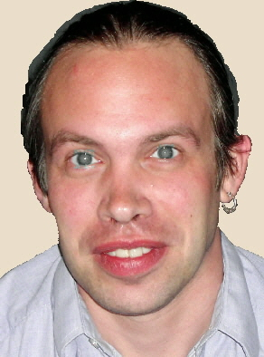 | A Novelist Idea  by Mark Russell  “Can you recommend a good book?” My fellow librarians and I work very hard to always be prepared for this question, but sometimes even the
  most experienced librarian needs assistance in finding the right book. In library parlance, we call this process “readers’ advisory,” and there are a wide variety of tools that both librarians and the public at large can use to track down that perfect title. One of the best of these readers’ advisory tools is Novelist.
  Novelist is a database for fiction readers’ advisory that can be accessed for free from the Carnegie Library of Pittsburgh website (www.carnegielibrary.org). Anyone can view Novelist using a library computer, and library card holders can view it from any internet-accessible computer. It can be found on the CLP website in the “Articles, Databases, and More” section.
  If you search for a particular title in Novelist, you will immediately be given a list of ten books that are similar. For example, if I read Gillian Flynn’s Gone Girl and really enjoyed it, Novelist recommends that I try Defending Jacob by William Landay and The Silent Wife by A.S.A. Harrison. If Jojo Moyes’ Me Before You is a favorite of mine, Novelist has picked out Elizabeth Berg’s Talk Before Sleep and Jonathan Evison’s The Revised Fundamentals of Caregiving as others I may like. Perhaps I’m a John Grisham fan and I really liked his latest, Gray Mountain. According to Novelist, I should also try Elmore Leonard’s Raylan and Jeffrey Deaver’s The October List.
  Novelist’s Author Read-Alike section can help you find authors who are like your favorites. For each author listed in read-alikes, Novelist will provide at least five similar authors, list reasons why they are similar, and give a few selections of books to try. Readers of David Baldacci, for example, are encouraged to try novels by James Grippando and Kyle Mills, particularly Grippando’s Found Money and Mill’s Free Fall.
  There are many other features in Novelist to explore, including versions for children and teens. Using Novelist, you can find award-winning books, books that take place in a specific time period or geographical setting, or books from a multitude of genres and sub-genres. Novelist can exponentially expand your reading horizons, and I heartily encourage you to give it a try. To know more about Novelist, or for help using it, just ask a librarian.
seems that every movie that is not based on a comic book is based on a young adult novel! I claim no responsibility.

Holly Atherton’s remarks on page 2 appeared on the library’s blog site, where many CLP staff members share their love of all things bookish and “library-an”. It’s worth following at http://eleventhstack.wordpress.com.

The photos with Holly’s blog are priceless; check them out at http://eleventhstack.wordpress.com/2013/05/10/no-need-to-apologize-to-your-librarian. While I was there, I found another interesting blog, by Melissa F. Some very abbreviated excerpts:
Andrew Carnegie’s Favorite Day
We have a day for giving thanks. We have two for getting deals. Now, we have GivingTuesday*, a global day dedicated to celebrating generosity and giving.

I can’t speak for the guy, but I’m pretty sure that if he were still around, today would be one of Andrew Carnegie‘s favorite days of the year.

This whole idea of #GivingTuesday? I think he would have loved it.

(Connecting people with the idea of giving back to one’s community? Been there, done that. Got the Library system to prove it.)

“My aspirations take a higher flight. Mine be it to have contributed to the enlightenment and the joys of the mind, to the things of the spirit, to all that tends to bring into the lives of the toilers of Pittsburgh sweetness and light. I hold this the noblest possible use of wealth.”

Those were his very remarks during his presentation of the Carnegie Library to the People of Pittsburgh on November 5, 1895.

Which, y’know, just happened to be on a Tuesday.

*On Tuesday, December 2, 2014, CLP got $6,730 through Giving Tuesday, a project of the United Nations Foundation and New York’s 92nd Street Y that was created in 2012. The Pittsburgh Foundation’s Day of Giving, established in 2009, brought us $76,520.44 earlier in 2014.
Stephen Colbert told John Green, author of the YA novel The Fault In Our Stars, on “The Colbert Report” of 6/24/14:
As far as I can tell, a young adult novel is a regular novel that people actually read.
Genre Book Club meets the third Wednesday of the month at 6:30 PM

January 21 Men We Reaped, a memoir by Jesmyn Ward. Ms. Ward is the February author for the Pittsburgh Arts and Lectures Literary Evenings.

February 18 the historical novel The Chaperone by Laura Moriarty.

March 18 Rainbow Rowell’s YA [Young Adult] title Eleanor and Park.

Squirrel Hill Adult Book Discussion Group meets the fourth Thursday of the month at 1 PM

Jan 22 Empty Mansions: the Mysterious Life of Huguette Clark and the Spending of a Great American Fortune
by Bill Dedman

Feb 26 No Place To Hide: Edward Snowden, the NSA, and the U.S. Surveillance State by Glenn Greenwald

Mar 26 Soldier Girls: The Battles of Three Women at Home and at War by Helen Thorpe
5
CARNEGIE LIBRARY OF  PITTSBURGH – SQUIRREL HILL  5801 Forbes Avenue  Pittsburgh, PA 15217-1678  Adult Services: 412-422-9650  Children's Services: 412-422-9841  Fax: 412-422-5811  www.carnegielibrary.org/clp/sq  http://www,facebook.com  /clpsquirrelhill | ADDRESS SERVICE REQUESTED  your donation is tax deductible as a charitable contribution | 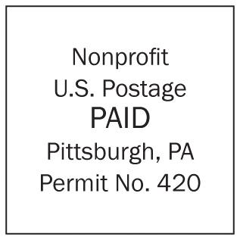
Is your Friends Membership up to date? Please check your mailing label. ➔
If the date is before 1/15, you need to renew. Mail us the form below or leave it at the library Service Desk..
Free Tax Services IRS-trained AARP Volunteers will offer free tax services to the public from Feb 2 through April 13, Tues & Thurs Noon – 3:00 PM and Sat 10:00 AM – 3:00 PM. Registration will begin January 21, 2015. Register by calling
the library at 412-422-9650 or asking a librarian. The library has all the popular federal, state, and city tax forms available.

January 2015 Among Friends Volume IX, No. 1

 | BOOK SALE NEWS  by Pat Bender  Squirrel Hill is one of the lucky, happy places where people take real pleasure and | January: Vera Rufkin  oils  February: Gabriel Burston  unknown medium  March: Bebbe Sagalar  oils  Our schedule is full  through  January, 2016.  If you’d like to  exhibit after that,  contact Marion Damick,  412-521-3075.  No pessimist ever discovered the secret of  6  the stars, or sailed to an uncharted land, or opened  a new doorway for the human spirit.  Helen Keller 1880-1968 | Make checks payable to:  Friends of the Squirrel Hill Library  and mail to:  Allison L. Marciszyn  2309 Woodstock Ave  Pittsburgh, PA 15218  SqHiFriendsLib@gmail.com  Check one box:  New Member Renewal  Check one or two boxes:  $5.00 $10.00 $15.00  $25.00 $50.00 Other ____  DONOR (the first year is free, but we  gladly accept donations.)  Name:___________________________________  ^{(Last)} ^{(First)}  Address: _________________________________  City/State: __________________Zip: __________  Phone(s): ___________________Date: _________  E-mail address: ____________________________  Please check all activities you can help with:  Stocking Book Sale Shelves Library Advocacy  Sorting Used Books Gardening  Keeping Sale Shelves Neat Publicity  COMMENTS:
   | Art  at the  Squirrel Hill  Library
interest in their library. One of the ways they show their appreciation for our work is with the quality and quantity of their book donations. We hope it never stops.

Please think about volunteering for a few hours at least one day a week. We need help with many small jobs or with the really big ones: sorting through new donations, scanning books on the computer, and boxing books for special events. This is all fun and really rewarding.

We really enjoyed having the holiday sale and hope to do more special sales in the coming year. It was fun to have additional items to sell for the holidays and we hope that you will continue to donate "gifty" things and small, fun, decorative items throughout the year.

Happy New Year!

